**Cyber-security Considerations for Safety Critical Systems**

To

*Benjamin Schroeder , Rolls-Royce*

*Professor Wayne Padgett, Rose-Hulman Institute of Technology*

From

*Team 16*

*Paul Earhart, Haoran Geng,*

*Dustin Kline, Larry Kozlowski*

*February 19th, 2018*

**Executive Summary**

*The Controller Area Network (CAN bus) is currently and has been the de facto protocol used in the automotive industry since the early 90’s. Given its staying power in such an influential industry, there is no doubting the usefulness of the CAN protocol. However, since the automotive industry has reached the digital age there are new factors that need to be considered when deciding what protocol is utilized within an automobile, one of which is security against hacking. Therefore, with this project, our team has been tasked with testing and documenting the inherent cyber-security of a CAN bus as well as testing out potential minor additions that could be made to a CAN bus that would increase its security significantly. There were two major technical goals the team were trying to achieve by the end of the project: demonstrate the capability to compromise, or completely stop the flow of data on a CAN bus with three different hacks, and demonstrate the ability to detect when a hack was being performed on the CAN bus by two different methods. Besides the technical aspect, the overall end-goal of this project was for the team to be able to concisely demonstrate everything that was learned about CAN bus cyber-security to interested members of Rolls-Royce in such a way that the information could be used in the companies day-to-day engineering practices. As of the end of this project, all goals were met. There are two functioning CAN busses, one that is used to demonstrate the three different malicious attacks that can be performed on any automobile CAN bus with relative success, and the other bus that has protective measures implemented so the aforementioned attacks can be detected when ran on the bus.*

*As of the conclusion of our portion of this project, there is still progress being made by someone outside the team to determine the viability of adding encryption to the CAN protocol. The question being answered by this research is not whether the encryption would help increase the cyber-security of the system, but whether the encryption and decryption process can be completed in a timely manner without any perceivable hit to performance.*

# I**ntroduction and Project Overview**

With our transportation entering firmly into the digital and connected age, it is time to take a look into the security of these systems. Rolls Royce tasked us with researching how secure our current automotive control systems are, and how their security might be able to be improved and what considerations should be taken in their day-to-day engineering. This was to be accomplished by creating a model control system, attack this control system, and then creating a hardened version of our system that would detect these attacks. Finally, these systems, a user manual for them, and the gathered knowledge in the form of a white paper were to be provided to Rolls Royce along with a presentation of our findings.

These systems were designed with our stakeholders, shown below, in mind, from constructing our system with off the shelf parts to ensure the system was reproducible for further research and expansion by Rolls Royce, to ensuring that our system was low cost to the final client and consumer. These core features and our stakeholders’ priorities are also outlined below in figures 1 through 4.

|  |  |  |
| --- | --- | --- |
| **Stakeholder Name** | **Level of Importance** | **Description** |
| Rolls-Royce | Highest | The company supporting the research |
| Supervisor | Moderate | The faculty member overseeing the project |
| Manufacturer | Moderate | Company manufacturing and assembling vehicles |
| Clients | Highest | Customers buying RR products |
| Consumers | Lowest | Customers buying Client products |

*Figure 1 – A Table of stakeholders and their descriptions*

|  |  |
| --- | --- |
| **Feature Name** | **Feature Definition** |
| Safety | Research directly aids in safety and protection of all stakeholders |
| Security | Research directly aids in security by blocking or interrupting third party attacks |
| Affordability | Solution is low cost as to not lower margins |
| COTS | Solution is readily available and made with consumer-off-the-shelf components |
| Maintainable | Solution is easy repaired and replaced by technicians |
| Manufacturability | Solution is easily installed and uses existing technologies to create |

*Figure 2 – Table of features and their descriptions*

|  |  |  |  |  |  |  |  |
| --- | --- | --- | --- | --- | --- | --- | --- |
|  |  |  | **Stakeholders** | | | | |
| **Feature** | **ID** | **Attribute/Metric** | **RR** | **Supervisor** | **Manufacturer** | **Clients** | **Consumers** |
| Safety | A1 | User Inputs | 1 | 1 | 0 | 1 | 1 |
|  | A2 | ECU Management | 1 | 1 | 0 | 1 | 0 |
|  | A3 | Safety Control Systems | 2 | 2 | 1 | 2 | 0 |
| Security | B1 | Attack Bypass Measure | 1 | 1 | 1 | 1 | 1 |
|  | B2 | Attack Interrupt Measure | 1 | 1 | 1 | 1 | 1 |
| COTS | C1 | Built with Arduino | 1 | 0 | 0 | 0 | 0 |
|  | C2 | Built with Beagle Bone | 1 | 0 | 0 | 0 | 0 |
|  | C3 | OBDII Compatible | 1 | 0 | 1 | 1 | 1 |
| Manufacturability | D1 | Easily Installed | 0 | 0 | 1 | 1 | 0 |
|  |  | Totals | 9 | 6 | 5 | 8 | 4 |

*Figure 3 – Examples of which stakeholders care about what features and how we found their level of importance*

|  |  |
| --- | --- |
| Levels of Importance | Rating Scales |
| No Importance | 0 |
| Some Importance | 1 |
| High Importance | 2 |

*Figure 4- Rating Scales of the level of importance*

We created our model control system as a network of microcontroller based sensor nodes, connected by a CAN network, as one would find in a modern car. We then made a beaglebone based attack system, capable of performing three unique attack methods, and tested it against a real car to verify both that our control system behaved similarly to that of the car, and that our attack system and attacks were robust enough to be performed on a commercial system. A hardened version of our original system ,capable of detecting and reporting when it was being attacked, was then constructed to finish the hardware deliverables of the project. This report, along with a presentation to be given to Rolls Royce, completes our project deliverables.

# **Accomplishments**

To make a demonstration on vehicle hacking, we designed and implemented three different system. A car emulated system which uses a BeagleBone Black as the ECU (Engine Control Unit) and three arduino as different nodes. Arduinos collect different data and transmit them through the CAN BUS to the BeagleBone Black. The BeagleBone Black will analyze each data and display them on a LCD screen. This process emulates a simple car. The attack system uses a BeagleBone Black which can connect to the emulated car system and provide three different attack models which either defunctionize or mess up the emulated car system. The last system is the emulated car system which has the same functions as the first one, but it can detect attacks by the attack system. The detail of each systems will be provided in the following section.

## 2**.1 Description of the Solution**

To be able to research and demonstrate cybersecurity concerns in an automotive control system, we designed and built a platform agnostic model of a car control system that could be used as a test space. This model control system was comprised of four nodes connected by a CAN bus. Each of these nodes was in charge of a seperate piece of processing or sensing. Two of the nodes, a temperature sensing node and an engine RPM reporting node, acted as mock remote sensors, one was reported mock driver inputs, and one was acting as the central computing unit, known in a car control system as the Engine Control Unit (ECU). The system also had an external connection to the CAN bus emulating the On Board Diagnostics II (OBD II) port seen in a production car control system.

We also built an attack system to interfere with the model control system. The attack system assumed physical access to the control system, as specified by our client. This was accomplished in our system via a direct link to the CAN bus through the OBD II port. The attack system was then used to manipulate the CAN bus, allowing us to test and try to interfere with our model control system. To make sure that our research would be relevant to our client, the control system was designed to be platform agnostic, ensuring that the flaws we would exploit in our attacks and the hardening measures used to defeat these attacks could be transferred to the control systems our client builds.

Once these systems were implemented and our attacks were able to interfere with the operation of the model control system, we focused our efforts into creating a hardened version of the control system that could detect these attacks and alert the main processor in the network. Detection was decided as the goal of our hardening as the "what" to do in the event of an attack is largely circumstantial, but detecting the attack is always necessary regardless of what the response should be.

## 2.2 Data and Verification of Requirements

Table XX below was used for verification purposes. The base system (2.2.1) must meet the Safety and C.O.T.S. (commercial off-the-shelf) requirements. The attack system (2.2.2) must meet the C.O.T.S., Attack Models, and Portability requirements. The hardened system (2.2.3) must meet the Safety, Security, C.O.T.S., and Manufacturability requirements. See their respective sections below for more information.

|  |  |  |  |  |
| --- | --- | --- | --- | --- |
| Features | ID | Attributes/Metrics | Verified | Achievement |
| Safety | A1 | User Inputs have first priority | Inspection | Passed |
|  | A2 | ECU Management | Demo | Passed |
|  | A3 | Safety Control Systems | Inspection | Passed |
| Security | B1 | Attack Bypass Measure | Demo | Passed |
|  | B2 | Attack Interrupt Measure | Demo | Passed |
| C.O.T.S. | C1 | Built with Commercial off-the-shelf parts | Inspection | Passed |
|  | C2 | OBD-II Compatible | Inspection | Compatible with SAE J1962 connector |
| Manufacturability | D1 | Easily Installed | Inspection | Unverified |
| Attack Models | E1 | DoS (Denial-of-Service) | Experiment | Passed |
|  | E2 | Bus corruption via bitrate manipulation | Experiment | Passed |
|  | E3 | ID Replication | Experiment | Passed* |
| Portability | F1 | Battery powered | Inspection | Powered off a USB battery pack. |
|  | F2 | Can be used without another device | Inspection | Passed |

Table 5 - Overall Feature Verification * - See section 2.2.2

### 2.2.1 Base System

The base system must meet the overall Safety and C.O.T.S. requirements of this project. A1 and A3 were checked by an inspection through the Candump utility. A2 was verified by demonstration by using the potentiometers and buttons to adjust values and having the ECU update the dash cluster LCD. This can be seen in Video 1 in the video subdirectory and in Fig. 6 and Fig. 7 below. The figured can be compared to show the differences on the LCD depending on how the inputs were changed. The C.O.T.S. requirements were checked by inspection of the finished system. The system is built from BeagleBone Blacks and Arduino microcontrollers that are available at online retailers which meets C1. C2 is met by the CANH and CANL wires separated on the board which correspond to pins 6 and 14 respectively of the SAE J1962 connector.

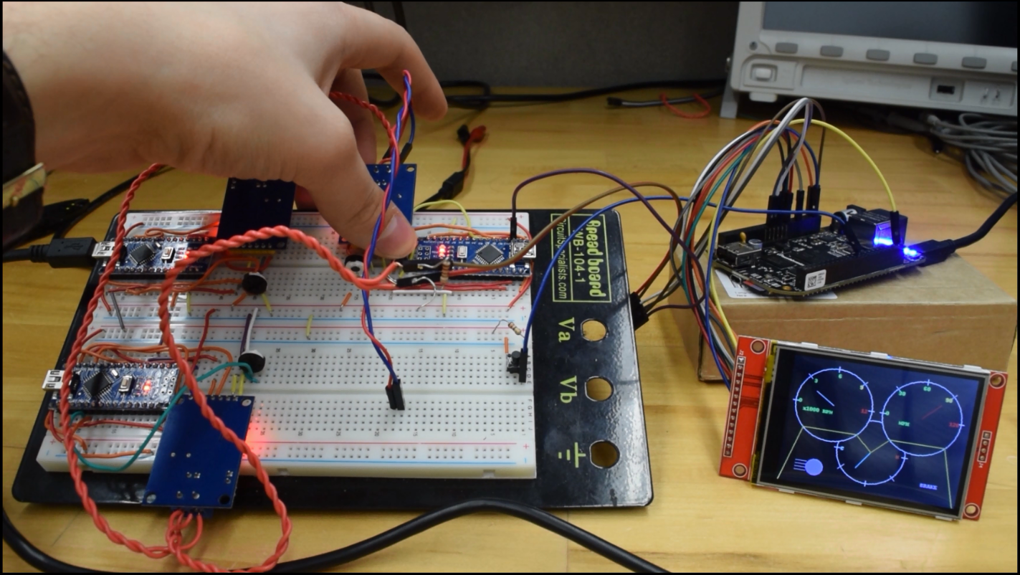

Figure 6 - Testing the “Brake” input (A2)

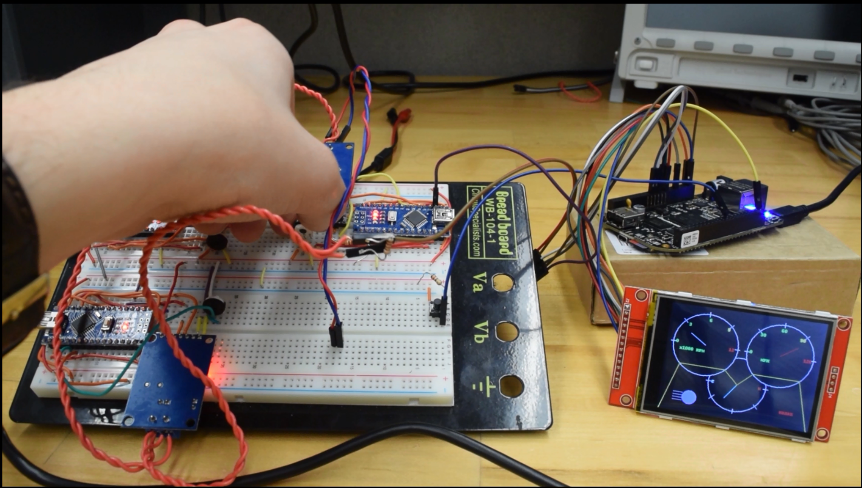

Figure 7 - Testing the “Vehicle Speed” input (A2)

### 2.2.2 Attack System

The attack system must meet the C.O.T.S., Attack Models, and Portability requirements of this project. C1 and C2 verification are the same as in section 2.2.1. F1 was verified by inspection as the system is ran off of an external C.O.T.S. USB battery pack. F2 was verified by inspection and is due to the BeagleBone Black running off of on-board eMMC and launching the attack script on startup. The system can be used with a laptop for a more advanced setup or by itself with the included buttons and mode-select RGB LED. E1, E2, and E3 were verified by experiment with the base system, hardened system, and a physical vehicle. The base system tests can be found in Video 2, the hardened system tests can be found in Video 3, and the physical vehicle tests can be found in Video 4 of the video subdirectory. In addition, screenshots from the videos are attached as Figs. 8, 9, and 10 as examples of each test. E1 passed in all 3 tests, E2 passed in all 3 tests, and E3 passed in the base and hardened system tests. E3 was difficult on a physical vehicle as it required deobfuscating raw CAN messages and we met a time crunch so the test wasn’t finished. While we weren’t able to test an ID and decode the CAN message, we did log the CAN bus of a 2009 Honda Civic which was plotted out to show how it could be accomplished. This can be seen in Fig. 11.

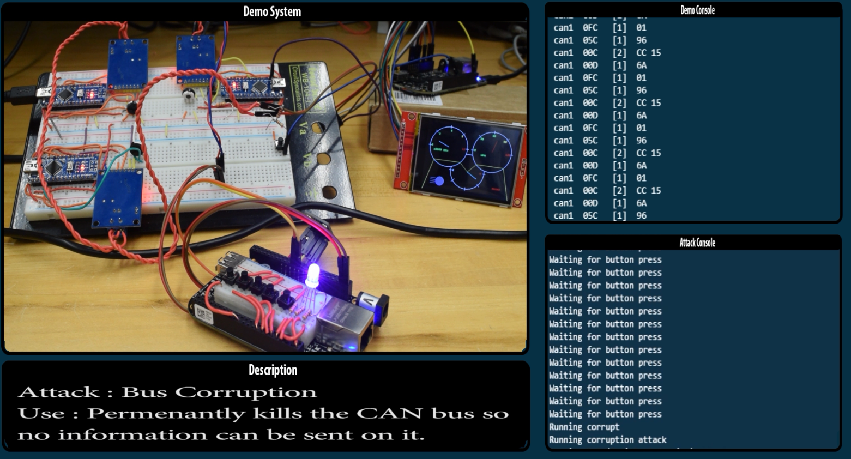

Figure 8 - Bus corruption attack on the base system showing that it stops the transmission on the bus. (E2)

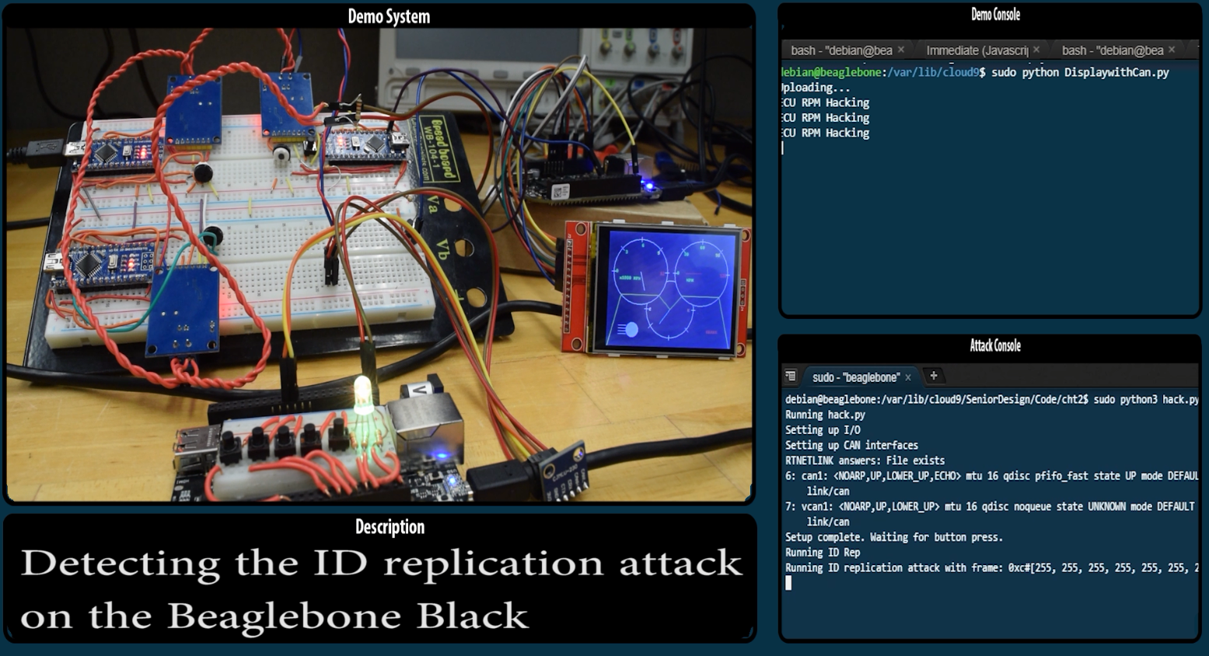

Figure 9 - ID Replication attack on the hardened system showing the message overriding what the arduino is sending and detecting the attack. (E3)

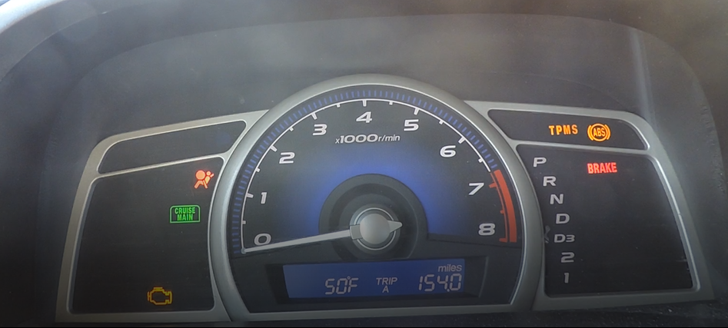

Figure 10 - DoS (Denial of Service) attack on a physical vehicle showing error messages on the dash cluster due to systems having issues sending messages on the CAN bus. (E1)

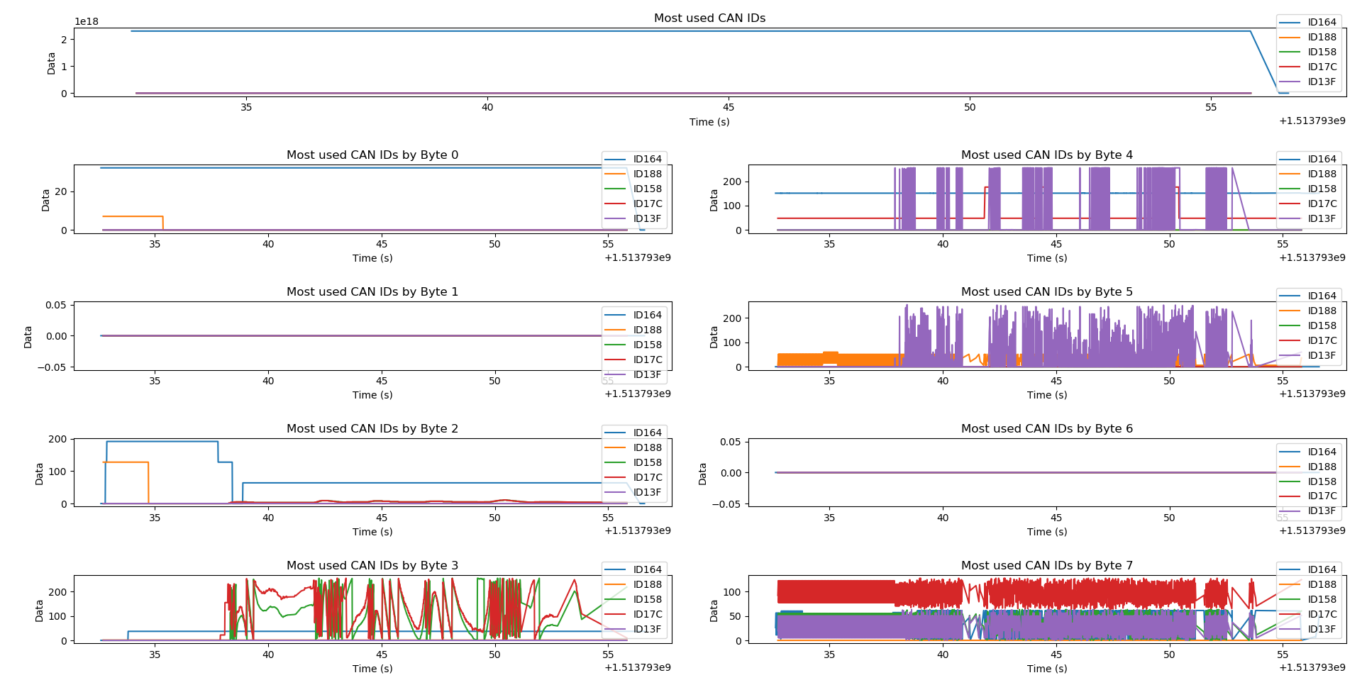

Figure 11 - CAN bus traffic logged from a 2009 Honda Civic and graphed by the most used CAN IDs and broken down by byte for future testing. (E3)

### 2.2.3 Hardened System

The hardened system must meet the Safety, Security, C.O.T.S., and Manufacturability requirements. Requirements A1, A2, A3, C1, and C2 are as described in section 2.2.1. B1 and B2 were verified by demonstration. The “Attack Bypass Measure” (B1) was checked by detecting any of the attack models and then telling the ECU to fall back to a seperate network. While we do not have a secondary or tertiary network to use as an alternative, detecting these attacks and telling the system the issue was enough for this requirement to pass. The “Attack Interrupt Measure” (B2) was checked by detecting the ID Replication attack model and sending an error frame on the CAN bus. Upon seeing the error message, the ECU will know which node is being replicated and from there can try to estimate which messages are reasonable based on the last known good value and the delta change between it and the incoming messages. B1 and B2 can be seen in the demonstration shown in Video 3 in the video subdirectory and in Fig. 12 and Fig. 13 below respectively. D1 is unknown at this time and depends on the encryption network designed by the additional team member which will be completed at a later date.

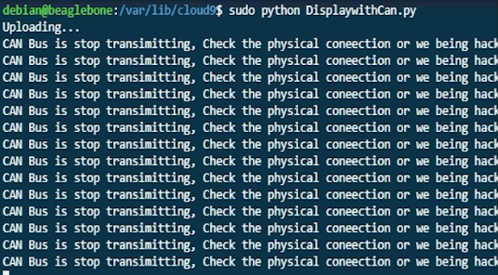

Figure 12 - Showing the ECU detecting the bus corruption attack which would be followed by switching to a secondary or tertiary network. (B1)

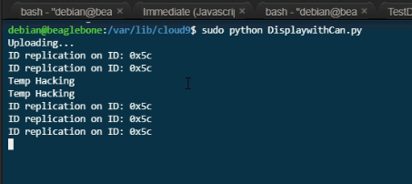

Figure 13 - Showing the ECU detecting the ID Replication attack model and showing the node ID associated with the attack. (B2)

# Project Plan and Timeline

### 

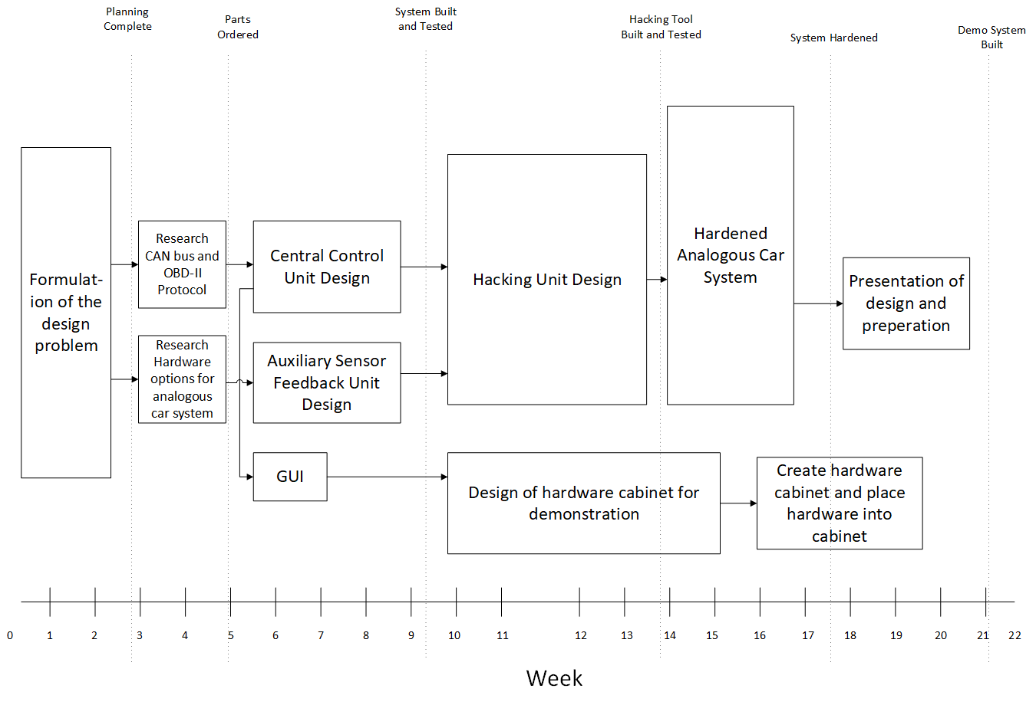

Figure 14 - Original PERT Chart

As with any engineering project, the first step was to sit down and brainstorm ideas for the final product. Since this project was exceptionally open-ended, it was up to the team’s discretion as to what the final product needed to be in order to satisfy the client’s needs. This required extensive communication between the team and the client at the start of the project. This is reflected above in Fig 14 with the “Formulation of the design problem” taking up the first three weeks of project time. Once the format and purpose of the final product was established, the team then needed to gain a better understanding of the technical knowledge that would be necessary for the creation of the product. This entailed understanding the CAN bus protocol so that the team would be able to replicate it on Consumer Off The Shelf (COTS) hardware. In tandem with researching the CAN protocol, we had to determine which COTS hardware would best serve our needs in being able to create our own functional CAN bus.

With initial research and planning finished, it was then time to start designing the individual components of our product. The team decided to split the CAN bus into two separate components: the Central Control Unit, known as the ECU in a vehicle, and the Auxiliary Sensor Feedback units. These two systems were separated because they had fundamentally different purposes, just like they would in an actual automobile. With these two systems properly running and interacting with each other the team would then have a fully functioning CAN bus that was fundamentally identical to an actual CAN bus.

With a CAN bus made and working, the next step for the team was to start running penetration tests on the bus to determine how well a CAN bus could withstand being hacked. In order to attack the CAN bus the team had to create a unit that was capable of connecting to the network, both to receive and send packets. This hacking unit was required to perform three distinct malicious attacks that any given vehicle could be susceptible to. The attacks performed by our hacking unit had to not only be successful on the teams designed CAN bus, but as well as an actual vehicle.

After the hacking unit was completed and fully operational, a new CAN bus had to be created. This CAN bus had measures put into that would harden it against the attacks that had been previously tested against the original CAN bus. It was imperative that this second CAN bus was made using identical hardware as the first CAN bus. It was also necessary that no changes were needed to be made to the hacking unit to be able to interface with either CAN bus.

With all of the technical aspects of the project completed, the last portion of the project required the team to organize everything that was learned and create a coherent and straight forward demonstration and presentation that would be shown to interested employees of the clients.

There is one path on Fig. 14 that branched off from the critical path once the hardware for all the systems had been purchased and physical design for the systems were being constructed. This path was not intrinsically tied to any technical progress for the project, but was no less important. This branch dealt with the overall presentation of how the systems would look and portray system status. The GUI would be designed to look and act similarly as a car’s dash cluster does. This was an important aspect to the system as it would be a visual cue for anyone looking at the system as to what it’s function was. Next, came the design of the overall case for the system. This included the LCD screen that displayed the GUI, the potentiometers and buttons that would act as variable inputs for the different sensor types in the system, and then the hardware of the system itself.

# 

# **3.1** Deviations From Project Plan

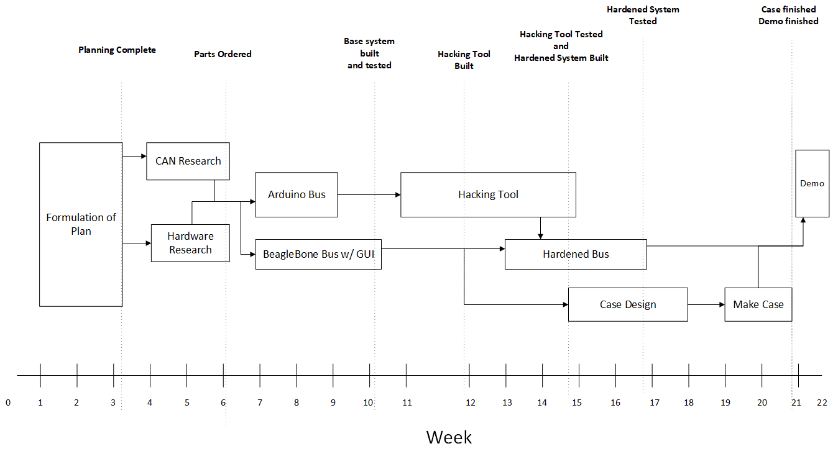

Figure 15 - Revised PERT Chart

The team did not start to deviate from the PERT chart in Fig. 15 until the original CAN bus was most of the way complete. The deviation occurred because the auxiliary sensor portion of the CAN bus, which was being handled by the arduinos, was significantly easier to set up than it was to get the central control unit, which was being handled by a BeagleBone Black, connected to the bus. This should not have come to a surprise to the team during the planning phase of the project. It is common sense that it would take less time to interface two arduinos with each other through CAN than it would to get an arduino and a BeagleBone interfacing with each other. The simplest course of action that would have prevented this discrepancy would have been to not have chosen the BeagleBone Black as the hardware that would act as our central control unit on our CAN bus, instead perhaps choosing a different, more powerful arduino than the models being used as the auxiliary sensor

With the two portions of the CAN bus at two different points of development, this pushed certain aspects of the project forward earlier than planned. The hacking system started being developed as soon as the arduino portion of the bus was completed. This was possible because even though the entire CAN bus was not fully constructed, as long as there were two nodes on the bus sending and receiving information on the bus then it was possible to test out the hacking tool. Once the development of the original CAN bus was finished and the BeagleBone was properly interfacing with the arduinos, portion of the team decided to start development on the hardened CAN bus even though the hacking tool was not yet completed. The team was able to start implementing cyber-security measures based on the attacks that had so far been developed on the hacking unit.

With development on the hacking tool completed and with the other portion of the team focusing efforts on hardening the CAN bus, it was then time to design and develop the case that would hold all the hardware. Starting to develop the case later than originally shown in the PERT chart in Fig. 15 ended up benefiting the team. At that stage in the project, the team had a better understanding of all the hardware they were dealing with and thus were able to design a case that fit the needs of the project.

The last deviation that needs to be mentioned is how the team handled the development of the GUI. As it turned out, the GUI was developed not as its own entity, bus in tandem with the central control unit. Development moved this way because it was determined that the LCD screen that was being implemented as the GUI worked as an excellent debugging tool for the central control unit. Once the LCD screen was properly interfacing with the BeagleBone, the team was able to display every package that was being received by the BeagleBone from the CAN bus. This was certainly a useful tool when debugging the overall functionality of the CAN bus.

Retrospectively, the deviations that occurred from the PERT chart shown in Fig. 14 were due to timing differences, not due to technical roadblocks or limitations. The final product of this project turned out how the team imagined it would, with the only differences coming from how the work was accomplished. Our progression of work was, in all actuality, more efficient than the Fig. 14 PERT chart ended up being. This experience would change the way our team would go about devising a PERT chart for now on. Different aspects of a project are never going to conclude at the same time. Therefore, having a more accurate understanding of how much time portions of the project need to be completed would allow the team to make a more accurate PERT chart, as well as force the team to think more in depth about the actions required to complete a certain task.

# 4. **Budget**

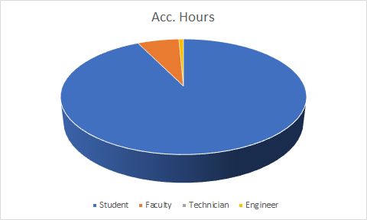

Figure 16 - Accumulated Hours Pie Chart

### 

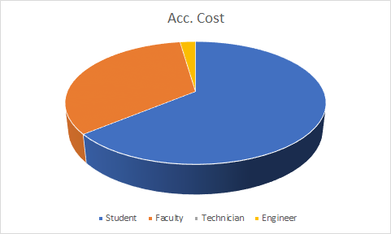

Figure 17 - Accumulated Cost Pie Chart

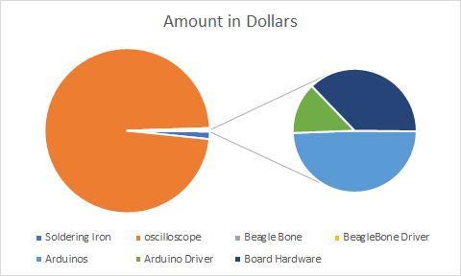

Figure 18 - Accumulated Cost in Materials, Supplies, and Equipment

It is no surprise that the highest cost in labor came from the hours of the student, as shown in Fig. 17. It is an important lesson for the students to keep in mind is how much the cost of man hours plays into the budget of a project. Time is money and all employees have salaries, which is why it is so critical in a business environment to have projects properly planned out from the beginning so there are not too many people dedicating their time to a task when it just isn’t necessary. It is important to note, however, when analysing the Faculty portion of both pies that the Faculty has a rather small portion of the overall hours pie, seen in Fig. 16, but then takes up close to a third of the accumulated cost pie, seen in Fig. 17. This goes to show that being able to solve one’s own problems without getting a supervisor involved is quite valuable and cost effective for a company.

The pie chart shown in Fig. 18 shows some striking data. Specifically how price of the oscilloscope used by the team ended up dwarfing the price of every other cost of the project. The prices of some of the equipment that are available to be used by the students at will certainly goes unappreciated at times. The oscilloscope was a crucial tool to the project, because it was an invaluable tool for debugging the CAN bus to verify that there were clean, and proper CAN packages being sent over the network. Even the soldering iron that was used to facet the components on perfboard cost more than the rest of the material and hardware used in creating the product. This just goes to show how much the initial cost of equipment plays into starting a new project.

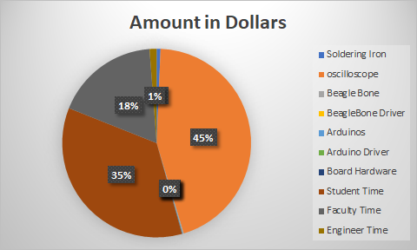

Figure 19 - Total Cost of Project

Figure 19 breaks down the cost of the entire project, with the total sum coming up to $44,861. The astonishing number to note is that the price of the oscilloscope comes to be nearly half the entire cost of the project. Despite the many hundreds of hours of work that went into the project it was this one piece of equipment that cost the most.

# 5. **Recommendations**

Given the fact that this project was research oriented, the bounds of what constitute a successful project in this case are abstract. The end goal for this project was the information that was learned about the cyber-security of CAN bus and how well the team would be able to relay that information in a useful manner to the engineers at Rolls-Royce. Therefore, to be able to quantify how successful the team was able to relay this newfound knowledge depends on how successful Rolls-Royce will be able to apply what they learn from the team, and what new directions Rolls-Royce was directed thanks to the team’s efforts.

Looking from a less abstract perspective, comparing the final product that was produced by the team with the Stakeholder features that were established early on in the project, it is clear that the conditions for success were met. Safety and security, both were the highest priority for this project. Every technical aspect of this project went into learning techniques that would heighten the safety and security of the products that were being made by the clients. Looking from the perspective of safety and security, the project was most satisfactory. The team demonstrated in depth understanding of fundamental cyber attacks that the client needs to be familiar with. The team was also able to demonstrate possible ways to detect the aforementioned attacks and posed possible measures that could be taken in order to shut down the cyber attacks all together. The project was also affordable. The team spent approximately half of their allotted budget. This went hand-in-hand with the requirement that the solution had to be constructed using consumer-off-the-shelf (COTS) components. This helped drive the price down as the solution was designed so there would be no need for any particularly specialized hardware. The solution was maintainable due to the fact that the construction was done with COTS. If a portion of the hardware went bad, a replacement part could be ordered and received in a matter of days. The manufactuability of the solution is straightforward since a CAN bus is never too complicated. The product could be reproduced by any engineer simply by following a wiring diagram and assembling it onto a breadboard.

Of course, since this project was research based there is always room for expansion. There is always more that can be learned and taught. From a safety and security standpoint, the team could always learn more about different attacks that are presently being using on vehicles. The team covered three main attacks, but many more exist. A decision was made that the best course of action for this project was to get as in depth as possible on those three attacks instead of covering a menagerie of attacks but not being able to dive deep into their technical aspects. From an affordability standpoint, there were two aspects of the project that could have been executed better. The first being the two beaglebones that were bought. Getting the beaglebones to interface with the arduinos and CAN drivers at the beginning of the project turned out to be a roadblock. In hindsight, the better choice of action would have been to pick another, more powerful, arduino to use as the central control unit on the CAN bus instead of the beaglebone since it would have been much simpler to get to interface with the other arduinos as well as a cheaper solution. Going the other way, the team should have bought a higher quality LCD screen than the one that was bought and used as the GUI in the solution. Given the low quality of the LCD screen that was used in the solution, the team had to fight refresh rate issues throughout development. These issues were significant enough that it had affected the ability of the team to be able to demonstrate the knowledge that was gained throughout the project to the client. Given that the overall ability to demonstrate the knowledge gained was the team’s highest held tenet, the issue caused by the LCD screen was the team’s biggest regret.

From the perspective of teamwork, there were no significant issues with how the team were able to conduct themselves. Sometimes the meetings would drift off topic from what was meant to be discussed or accomplished. Perhaps going into meetings with more discrete goals about what needed to get done before the team could leave would have pushed the team to get more work done earlier in the project. Something else to consider would be the condition in which members would show up to meetings. Sometimes members of the team would show up to meetings at less than their best condition, leading to having less presence and influence than normal. When the team had originally discussed the rules that the team would set to uphold, a rule in which handled a situation where a member knew they would not be in a state to fully contribute to the meeting would have perhaps made for more successful meetings throughout the project.

As with any research project, there are always new direction to expand too. One aspect that is being explored currently by a late addition to the team is encryption. Encryption of information has always been an excellent way to secure and protect the information from getting to agents that should not have the information. The issue with performing encryption on a CAN bus is that encryption takes time, and this delay could provide a different type of safety risk to the driver of a vehicle. Researching ways to make the encryption process fast enough to where the delay is short enough that there is no noticeable performance hit to operating a vehicle would be a huge breakthrough in securing the modern vehicle from hackers. As stated before, there is a member to the team that joined more than halfway through the project and is working on this research individually. What information that has been gathered from this research will be presented to the client. Then, of course, expanding on the number of attacks that the team could be able to demonstrate and protect against would provide useful knowledge to the client. Given how there are countless numbers of cyber-security exploits that could be performed against a CAN bus, continually researching similar concepts between these attacks and implementing a detection mechanism would help the client be able to apply new design practices amongst their engineers that could impact the industry standard of vehicle communication networks in a positive manner.

# 6. **Going Further Material**

The following sections cover additional material not directly related to the technical aspects of this project yet provide some insight on the implications that this project could provide if looked at from a larger scale.

## 6.1 Standards

CAN (ISO 11898) is the standard used for connecting devices in an automotive network. The standard specifies the data link layer (ISO 11898-1), the high-speed physical layer (ISO 11898-2), and the low-speed physical layer (ISO 11898-3). Our design uses the ISO 11898-1 and ISO 11898-2 standards for creating our CAN bus. By the specifications, we are using two 120 ohm terminating resistors on the end nodes, running at a bitrate of 500KBPS, and following the CAN packet formatting as described.

ISO-TP (ISO 15765-2) is a standard used for sending large packets of information on the CAN bus that exceed the 8 bytes used in CAN (ISO 11898). This is used for firmware updates and UDS (ISO 14229-1) services. UDS (Unified Diagnostic Service) is used for troubleshooting ECU’s in a vehicle. We use this for the UDS query attack for finding possible ECU’s that we could target.

These standards can be purchased at the following links: Prices are rounded up from current exchange rates for USD.

ISO 11898-1 <https://www.iso.org/standard/63648.html> ($200 USD / CHF 178)

ISO 11898-2 <https://www.iso.org/standard/67244.html> ($150 USD / CHF 138)

ISO 11898-3 <https://www.iso.org/standard/36055.html> ($130 USD / CHF 118)

ISO 15765-2 <https://www.iso.org/standard/66574.html> ($200 USD / CHF 178)

ISO 14229-1 <https://www.iso.org/standard/55283.html> ($215 USD / CHF 198)

## 6.2 Manufacturability/Safety

The research we did affects manufacturability in respects to firmware updates and dumb-nodes. For vehicles to take advantage of the detection methods we used, they would need software updates to be able to look for their IDs and send a different packet. Dumb-nodes, or nodes that contain multiple sensors that can only send their current values, need to be passed through an ECU and the ECU use the detection methods. This makes the cost of software development and technicians to push these updates increase the total cost of manufacturing. If future hardware were made with these detection methods in mind, the cost would be negligible compared to legal fees and firmware updates would be unnecessary on newer parts. One way to accomplish this would be to add a setting pin to all nodes that could be bridged to ground to enable the security features. This gives the option of having the more secure operation and being backward-compatible with older systems going forward which would save on creating multiple SKUs for the different operating nodes and saving on production costs associated with the multiple parts.

Safety comes in the form of security. With the CAN network being secured through obscurity, it takes very little to gain access and control different parts of a vehicle. Our research mainly focused on detection, but that is only half of the problem. After detecting an issue, its up to the company or engineers to find a solution that will work. The solutions that we came up with were fall-back networks and reasonableness checks. An issue with the fall-back or redundant networks is that it adds complexity and cost and is only a time gate for a malicious actor to gain access to the next network in the chain. Reasonableness checks like the state estimator and multiple ID detection have the advantage of being able to throw out odd data from a malicious actor, but can cause issues when collisions occur as sensor readings would change drastically over the set deltas. In a collision scenario, we could theoretically throw out data that would save someone's life like deploying an airbag. This is one of the main reasons we decided to stick to detecting a malicious actor as our abstraction layer, as there are a lot of scenarios that we do not have enough information on to make informed decisions. These scenarios will need to be added to the state estimator or other reasonableness checks at a later date.

## 6.3 System Failure Mode Analysis

#### 6.3.1 CAN Connection Error

CANL and CANH wires are a common failure mode of the CAN bus. If the wires become disconnected or swapped it brings down the network and causes the CAN bus to malfunction. While this is only a concern during manufacturing in most vehicles, our base and hardened system met this failure commonly when adding a new node to the system or adjusting parts. The screw terminals that were used for connecting the CANL and CANH wires are not secure and it would be suggested to solder these connections or use a wire harness like what is used in a real vehicle to keep the wires from being disconnected due to stress on the connections. The failure can be detected by disconnecting the newest addition to the network and checking the wires by an inspection to make sure they are connected correctly and securely.

#### 6.3.2 Attack System User Error

The system can also fail by user error if they do an unexpected action when running the attack system code. Some features of the attack system, namely the corruption attack and the can logger, do not support canceling the operation through the use of the external push buttons. If a user presses one of these buttons during operation, there is a chance that the python program will crash and depending on the operation can make the system unoperational. A risk associated with the corruption attack is permanently disabling a CAN network while the attack system is attached. This will happen everytime it is canceled due to how SocketCAN changes the bitrate using terminal commands. Detecting this issue can be done by disconnecting the CANL and CANH wires of the attack system from the test systems and inspecting if data is being sent on the CAN bus. The real fix to the issue is to modify the linux kernel on the attack system so that it can handle the network changes, but as a temporary solution rerunning the python program will reset the connection and bring the network back up.

# 6.4 Societal Impact

Perhaps an interesting point of view to take in this section, is not the societal impact of this project if it were expanded to large scale, but the societal impact of this project if it were not. The days are long gone where hackers were a rare breed, a single person who had been dedicated to the art for years to become a successful one. With the resources and hardware available online anymore, anyone can become a successful hacker in a short amount of time. This is why cyber-security has become such a high priority in the technical world and such a huge buzzword in the media. The car industry has been notorious for being slow to integrating new technology, but it recently has started adding new features and technologies to vehicles on the market. All of these features are based around computers and connectivity.

Yet, the cyber-security of these features has been proven to be meager at best. A quick google search shows enough proof out there for this claim, and would put fear into anybody who feels safe in a new, connected vehicle. The societal impact of not researching and upping the inherent cyber-security of new and older vehicles would show gross incompetence. There are examples of people being able to to take full control of moving vehicles remotely. This example alone shows the great potential out there for the great harm that could be done. It would take just one large-scale attack from hackers to put the entire industry on its back. With the right tools, a single group of hackers could possibly shut down an entire car manufacturers fleet. The repercussions and political backlash from something like this would be massive. This would reverberate on a global scale.

This project goes to show that there are defensive measures that could be taken that are miniscule in the grand scheme of things that could potentially prevent massive-scale attacks from taking place. It is impossible to make any vehicle fully hack-proof, but it is possible to prevent the worst case scenarios from occuring. This project shows that the companies with the most at stake from these types of attacks have their minds in the right places and are making small step in the proper direction to help create a more secure future.

## 6.5 Economic Impact

The economic impact and the societal impact are intrinsically tied to each other. If one were to look at this scenario from a negative point of view, if vehicle manufacturers do not start increasing the amount of cyber-security in their vehicles, then the economic impact could be astronomical. The world could face the largest market crash in the history of mankind. If the right groups got involved and were serious about exploiting the inherent lack of cyber-security in vehicles, it is possible that every modern vehicle manufactured in the last five years or more could be susceptible to cyber attacks. This would freeze the entire industry. Consumers would be terrified to buy new vehicles, and car manufacturers would have to cease production. Not only that, but they would have to pour tons of money into creating solutions to raise the cyber-security of their vehicles, both new ones being made as well as having to go and retroactively patching the vehicles that are already out in the world. It is not too difficult to imagine how difficult of a situation that could put the world economy in. This would not be a problem exclusive to one car manufacturer. Once a single car manufacturer got targeted, every other company would have to ensure the safety of their vehicles as well before they themselves got targeted. This would impact every single modern country in the world.

If one were to look at this scenario from a more positive point of view, then the economic implications of researching new cyber-security measures now are not so scary. It is no secret that preventative measures are always more effective than reactive measures, and this is what the vehicle manufactures now need to address. The fact that this project exists shows that these manufacturers have their attention on the correct issues. A manufacturer could invest a small percentage of their overall running costs a year into researching new ways to increase the cyber-security of vehicles and be better off for it. It could just take the findings of one small team of engineers to potentially prevent the scenarios that were stated above. Based on the findings of this project alone, it would just take adding some small self-awareness to the many sensors in the vehicles to be able to detect many of the attacks that would be used to attack a CAN bus. This would increase the overall cost of the vehicle, but this would be a fractional increase. Most consumers would most likely be okay with paying an extra couple hundred dollars on their vehicle to ensure that it is safe from being hacked.

## 6.6 Environmental Impact

This project would not have any abnormal effects to the overall environmental impact to a vehicle. It is well documented already how much an impact a vehicle has on the environment, but the hardware and features added to a vehicle based on this project would not impact a vehicle’s current contribution. Perhaps, however, if you extrapolate the scenarios mentioned above there are some cases where a large amount of waste hardware would be produced. If large-scale hacks occurred and the only fix involved the car manufacturers going and retroactively installing new hardware to their vehicles then any of the old sensors would end up becoming a non-insignificant amount of waste. Perhaps if the EPA were brought into this situation while car manufacturers were being proactive, instead of reactive, then a solution could be devised where newer hardware could be placed directly in conjunction with the hardware already in place on the already manufactured vehicles. Of course, this would result in more hardware overall, and in turn more waste, but hopefully these fixes would be made with the environment in mind.

# 7. **Bibliography**

**Annotated List of Research Memos**

[1] Larry Kozlowski, Research Memo on XM Radio. September 28, 2017. “Research Memo” section of ROM.

*This memo was from researching ways to access the CAN bus from sources other than the OBD-II port. We decided it wasn’t worth pursuing due to the non-agnostic nature of XM Radios and Infotainment systems.*

[2] Larry Kozlowski, Research Memo on Bluetooth Entry Points. September 28, 2017. “Research Memo” section of binder.

*This memo was focusing on using bluetooth as an attack vector for accessing a vehicles CAN bus. In general it can be done, but we decided against using this approach and instead assumed that the malicious actor had access to the CAN bus and didn’t need to figure out a way onto it.*

[3] Paul Earhart, Research Memo on Open Source ECUs. September 25, 2017. “Research Memo” section of ROM.

*An option we gave ourselves for a test bench. We ultimately dropped the idea and used BeagleBones and Arduinos instead.*

[4] Dustin Kline, Research Memo on OBD-II Can Bus. October 10, 2017. “Research Memo” section of ROM.

*Generic research on OBD-II and CAN that was used to get us started with the project. Contains specs and comparisons to other networks.*

[5] Haoran Geng, Research Memo on Dash Clusters. October 2, 2017. “Research Memo” section of ROM.

*Generic research on a dash cluster and the decision to use and LCD as a makeshift dash cluster to display information and graphics.*

**Annotated Bibliography**

[6] Asia-15-Evenchick-Hopping-On-The-Can-Bus-Wp.Pdf. <https://www.blackhat.com/docs/asia-15/materials/asia-15-Evenchick-Hopping-On-The-Can-Bus-wp.pdf>.

This paper goes over the use of the CANard (renamed Pyvit) libraries and their uses. This was

used as a basis for the attack system python program.

[7] IOActive_Adventures_in_Automotive_Networks_and_Control_Units.Pdf.<https://ioactive.com/pdfs/IOActive_Adventures_in_Automotive_Networks_and_Control_Units.pdf>.

This document goes over the possible attacks a malicious actor could do to a vehicle over the

CAN bus. This was used to determining the more common attacks we could present.

[8] IOActive_Car_Hacking_Poories.Pdf.<https://ioactive.com/pdfs/IOActive_Car_Hacking_Poories.pdf>.

This document shows testing methodology for creating a test bench that can be used for

researching the CAN bus and automotive standards. This was used in designing our base system.

[9] Kuchera, Kenny. “How to Hack a Car — a Quick Crash-Course.” FreeCodeCamp, 21 June 2017,<https://medium.freecodecamp.org/hacking-cars-a-guide-tutorial-on-how-to-hack-a-car-5eafcfbbb7ec>.

A general article over how to connect to a CAN bus, collect data, and spoof traffic. This was

used as a starting point for debugging the base system and generating attacks.

[10] Pyvit: Python Vehicle Interface Toolkit. 2013. Linklayer Labs, 2018. GitHub,<https://github.com/linklayer/pyvit>.

A python library for interfacing with the CAN bus with support for SocketCAN and CANtact.

This is the main library used in the attack system.

[11] Smith, Craig. The Car Hacker’s Handbook: A Guide for the Penetration Tester. No Starch Press, 2016.

This book goes over a few common attacks and model-specific attacks that can be performed on

a vehicle. This was used for clarification of how a vehicle’s CAN bus works and was a starting point

for the attack system.

[12] Thorne, Brian. Python-Can: The Can Package Provides Controller Area Network Support for Python Developers. 2016. 2018. GitHub,<https://github.com/hardbyte/python-can>.

A python library for using CAN. This was used on the BeagleBone Black portion of the base and hardened systems.